ASSIGNMENT – 08 (DBMS LAB)

* **PROBLEM:**

Create the following table client_master.

* **PROGRAM:**

create table client_master (client_no varchar2(6),name varchar2(20),address1 varchar2(30),address2 varchar2(30),city varchar2(15),state varchar2(15),pincode number(6),bal_due number(10,2),primary key(client_no));

* **OUTPUT:**

Table created.

* **PROGRAM:**

begin

insert into client_master values('0001','Ivan','','','Bombay','Maharastra','400054',15000);

insert into client_master values('0002','Vandana','','','Madras','Tamilnadu','780001',0);

insert into client_master values('0003','Pramada','','','Bombay','Maharastra','400057',5000);

insert into client_master values('0004','Basu','','','Bombay','Maharastra','400056',0);

insert into client_master values('0005','Ravi','','','Delhi','','100001',2000);

insert into client_master values('0006','Runkini','','','Bombay','Maharastra','400050',0);

end

* **OUTPUT:**

Statement processed.

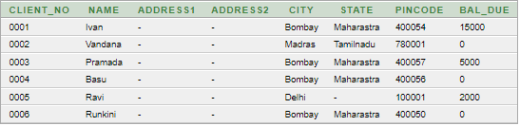

* **PROBLEM:**

Create the following table Product_master.

* **PROGRAM:**

create table product_master (product_no varchar2(30),description varchar2(20),profit_percent number(30),unit_meausure varchar2(30),qty_on_hand number(30),reoder_lvl number(30),sell_price number(6),cost_price number(10),primary key(product_no));

* **PROGRAM:**

begin

insert into client_master values('0001','Ivan','','','Bombay','Maharastra','400054',15000);

insert into client_master values('0002','Vandana','','','Madras','Tamilnadu','780001',0);

insert into client_master values('0003','Pramada','','','Bombay','Maharastra','400057',5000);

insert into client_master values('0004','Basu','','','Bombay','Maharastra','400056',0);

insert into client_master values('0005','Ravi','','','Delhi','','100001',2000);

insert into client_master values('0006','Runkini','','','Bombay','Maharastra','400050',0);

end

* **OUTPUT:**

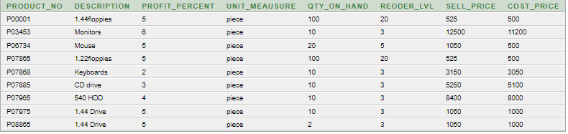

* **PROBLEM:**

Find out the names of all the clients.

* **PROGRAM:**

select name from client_master;

* **OUTPUT:**

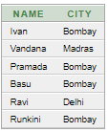

* **PROBLEM:**

Retrieve the list of names and cities of all the clients.

* **PROGRAM:**

select name,city from client_master;

* **OUTPUT:**



* **PROBLEM:**

List the various products available from the product_master table.

* **PROGRAM:**

select description from product_master;

* **OUTPUT:**

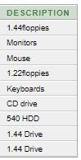

* **PROBLEM:**

List all the clients who are located in Bombay.

* **PROGRAM:**

select name from client_master where city='Bombay';

* **OUTPUT:**

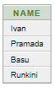

* **PROBLEM:**

Display the information for client no 0001 and 0002.

* **PROGRAM:**

select name,address1,address2,city,state,pincode,bal_due from client_master where client_no='0001' or client_no='0002';

* **OUTPUT:**



* **PROBLEM:**

Find the products with description as '1.44 drive' and '1.22 Drive'.

* **PROGRAM:**

select * from product_master where description='1.44 Drive' or description='1.22 Drive';

* **OUTPUT:**



* **PROBLEM:**

Find all the products whose sell price is greater then 5000.

* **PROGRAM:**

select * from product_master where sell_price>5000;

* **OUTPUT:**

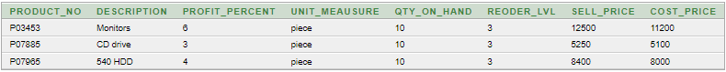

* **PROBLEM:**

Find the list of all clients who stay in in city 'Bombay' or city 'Delhi' or 'Madras'.

* **PROGRAM:**

select name from client_master where city='Bombay' or city='Madras' or city='Delhi';

* **OUTPUT:**



* **PROBLEM:**

Find the product whose selling price is greater than 2000 and less than equal to 5000.

* **PROGRAM:**

select * from product_master where sell_price>2000 and sell_price<=5000;

* **OUTPUT:**



* **PROBLEM:**

List the name, city and state of clients not in the state of 'Maharashtra'.

* **PROGRAM:**

select name,city,state from client_master where state!='Maharastra';

* **OUTPUT:**

